Project Title | 2020004 Goodall Brook Restoration Project, Phase II
Applicant’s Organization | City of Sanford
Project Start Date | April 1, 2020
Project Completion Date | March 31, 2022

- Waterbody and Watershed Information

  - Background

Waterbody Name | Goodall Brook
Waterbody Size (e.g., lake acres, stream miles) | 1.54 miles
Watershed Area (in acres or square miles) | 489 Acres
Watershed Location (town(s), county(s)) | Sanford
Title and Date of Existing or Past Watershed- based Management Plan | Goodall Brook Watershed Based Management Plan, December 2014
Public Access to Waterbody | Yes - Network of trails in two parks and City property at Seneca Street and Park Street

  - Waterbody and Watershed Physical Characteristics
Goodall Brook’s headwaters are located in a forested area along Hanson Ridge Road. At Grandview Avenue, the stream is diverted into a series of pipes and then flows nearly 2000 feet underground until it emerges at Lebanon Street. It then flows southeast through Sanford and then into a large forested wetland before flowing into the Great Works River, which then flows into Bauneg Beg Lake in Sanford and North Berwick, ME. Bauneg Beg Lake has over 200 lakefront homes, a summer camp and a Town park. From the lake, water flows into the Salmon Falls River (a drinking water supply for towns in ME and NH), and into Great Bay and finally the Atlantic Ocean.

The Goodall Brook watershed is predominantly developed, with 321 acres (66%) of the watershed consisting of residential or commercial land uses. The northeast boundary of the watershed abuts the City’s downtown, one of Sanford’s most dense residential neighborhoods, and major crosstown transportation corridors. Impervious cover (IC) within the watershed is partially created by Sanford’s City Hall, the Mainers baseball stadium and several businesses along Main Street. There are approximately 132 acres (27%) of forest land in the watershed, located primarily in the northern portion of the watershed. Impervious cover totals approximately 23.7% (138 acres) of the Goodall Brook watershed.

Description of Waterbody Uses and Value
A network of public trails exists within the watershed, including those in Soldiers and Sailors Park. Public access points exist within the watershed as well, via city owned land at Seneca Avenue and Park Street. Maine Inland Fisheries and Wildlife stocks brook trout in the lower reaches of the stream, creating a managed population of brook trout. There is endangered Hessel’s Hairstreak habitat within the watershed and Species of Special Concern, Eastern Ribbon Snake and Brown Snake habitat. There is also State Threatened Sleepy Duskywing Butterfly habitat.

Water Quality Problem or Threat

  - Water Quality Listing Status

Is water quality listed as impaired? | Yes
If impaired, what is the listed cause(s) and/or impaired use? | Streams - benthic macroinvertebrate bioassessments and habitat assessments.
Name and date of any DEP TMDL report(s) for the waterbody. | TMDL Assessment Summary, Goodall Brook – 12/29/2012

  - Water Quality Overview
After Goodall Brook was first assessed by Maine DEP in 2004, the Department determined Goodall Brook did not meet its Class B aquatic life criteria. As a result, Maine DEP listed Goodall Brook as impaired on its 2012 303(d) list. Subsequent monitoring also indicated that the Brook did not meet applicable criteria for dissolved oxygen or bacteria concentrations. Goodall Brook was included in the Maine DEP Impervious cover TMDL (2012). Historic dredging, widening and straightening of the stream channel has left the majority of Goodall Brook as a wide, slow moving stream with thick, soft sediments along the bottom. This type of habitat is not able to support the diversity of aquatic life necessary to meet Class B standards for aquatic life in the stream. The problems associated with stream alteration are compounded by the high impervious cover (IC) in the watershed. Additional stressors have been identified that likely impair the biological communities in Goodall Brook, including poor habitat, low dissolved oxygen (DO), elevated nutrients and bacterial contamination.

Watershed Nonpoint Pollution Sources and NPS Mitigation Activities

- Summary of Watershed Assessments and Priority Nonpoint Pollution Sources
Since 2004, the Great Works River Watershed Coalition, Bauneg Beg Lake Association, York County Soil and Water Conservation District (YCSWCD), and DEP have conducted several watershed survey projects that included Goodall Brook. Project funding was provided, in part, from USEPA under Section 319 of the Clean Water Act.
- In 2004, YCSWCD and DEP conducted a watershed survey of the Northern Great Works River Watershed (#2003P04). This survey focused on soil erosion in the more rural parts of the watershed, but it also included a limited assessment of Goodall Brook.
- In 2007, the Great Works River Watershed Management Plan (#2004R07) was completed and included several recommendations for Goodall Brook.
- In 2009, the Goodall Brook Survey and Hotspot ID Project (#2007PP09) completed a stream survey and Neighborhood Source Assessment Hotspot Inventory to provide a more comprehensive overview of residential and commercial sources of stormwater pollution. The project also identified problem areas and restoration opportunities in the watershed and along the stream corridor.

From 2012-2014, the Goodall Brook Watershed Management Plan Development Project (#2012RT17) with USEPA funding through Section 319 of the Clean Water Act was completed. The project conducted watershed mapping, water quality monitoring and watershed assessments and determined that causes of the impairment to Goodall Brook are associated with past stream channel modifications, slow water velocity and poor variability in flow patterns. Other impacts to the stream include inadequate buffers and outfalls that disrupt stream hydrology and habitat. Four high priority stormwater retrofit projects, as well as six medium and four low priority projects were identified in the management plan.

Description of Watershed Activities to Address NPS Pollution
Stakeholders in the Goodall Brook watershed have been working toward restoring water quality and aquatic habitat in the watershed for over a decade. These activities include the following:
- 2007 – As part of the Northern Great Works River Watershed Improvement Project, Phase I (#2006R-2) invasive plants were removed, and native vegetation was planted along 80 feet of Goodall Brook. This project was funded in part by USEPA under Section 319 of the Clean Water Act.
- 2011 - Bauneg Beg Lake Association raised local funds and coordinated the installation of three tree box filters at Roberts St., adjacent to the parking lot of the Sanford Mainers baseball stadium.
- 2015 – The City updated its watershed map and posted it on its website. It is regularly referred to in permitting development in the watershed. The Goodall Brook committee formed to guide the Implementation process. Sanford Sewerage District completed maintenance tasks on several sewer and stormwater lines in the watershed, including cleaning and inspection via CCTV.
- 2016-2018- The City was awarded a grant funded in part by USEPA under Section 319 of the Clean Water Act to carry out the Goodall Brook Watershed Restoration Project, Phase I (#2016RT08). This project worked with high school students to establish a water quality monitoring program and addressed six high and medium priority stormwater retrofit sites and habitat improvement projects as identified in the 2014 WMP. These projects included managing stormwater discharge within the Kimball Street outfall, a woody debris installation of three hemlock root wads and attached trunks within the bank of Goodall Brook, maintaining and enhancing three tree box filters on Roberts Street, installing a biofiltration system near the Mainer’s Parking Lot and addressing stormwater runoff at West Elm Street.
- The Goodall Brook Committee continued to meet to monitor 319 implementation projects, investigate ways to manage invasive knotweed (particularly in project focal areas) and discuss priorities. The City contracted with YCSWCD to prepare an invasive vegetation management plan.
- The Sanford Sewerage District (SSD) has committed the SSD’s TV camera to inspect and verify who is on the SSD’s public sewer or has a private septic system within the Goodall Brook urban watershed. Additionally, the SSD will verify through active sewer accounts properties without SSD accounts. These activities are not counted as match in this proposal, but are notable activities related to the goals of the Watershed Management Plan (WMP).

It is anticipated that at least one additional phase will be needed to restore stream habitat geomorphology between Roberts Street and Berwick Road. Additional projects addressing bacteria, phosphorous and nitrogen inputs may also be addressed in an additional phase. Educational opportunities may also take place with aims to educate the public about the habitat benefits of woody debris install projects in streams.

Purpose
The overall purpose of the project is to restore the water quality and stream habitat in Goodall Brook. The Phase II project will address two remaining high priority habitat restoration sites from the watershed-based plan that were not addressed in Phase I, install stormwater treatment BMPs to treat runoff from West Side Village, continue to collect water quality monitoring data, and create a Technical Manual that includes stormwater standards reflecting elements of Maine’s Chapter 500 Rules.

Environmental Outcome
This project will help restore Goodall Brook and improve habitat conditions for aquatic life so that it meets Class B water quality standards. Work will include habitat restoration of approximately 550 linear feet of stream habitat through woody debris installation projects and treatment of stormwater runoff from West Side Village through tree box filter(s) reducing total nitrogen and phosphorous to approximately 4.7 -9.5 lb /year and 1.5 - 3 lb /year respectively. The long-term goal is to attain Class B standards for aquatic life and E.coli, and reduce phosphorous loading to the Brook.

Partner Coordination, Roles and Responsibility

The City of Sanford will coordinate outreach tasks, participate on the Goodall Brook Steering Committee, oversee habitat restoration and NPS abatement site work, conduct project outreach and develop the technical manual. The City of Sanford will purchase contractor services for the majority of the NPS abatement site work. The City will also assist in coordination of property easements for the proposed habitat restoration sites. The City of Sanford will use appropriate procurement procedures outlined in DEP’s NPS Grant Administrative Guidelines.

York County Soil and Water Conservation District (YCSWCD) will be a sub-grantee and will provide overall project management and administration; create a water quality monitoring sampling analysis plan (SAP); oversee and participate in water quality monitoring; and assist with NPS project planning including preparing Federal, State and local permit applications for both habitat restoration sites and coordinating an amendment of a property easement for one of the habitat restoration sites.

Bauneg Beg Lake Association (BBLA) will continue to participate on the Goodall Brook Steering Committee and assist in public outreach.

Sanford Sewerage District will assist with water quality monitoring and will allow the use of its materials, equipment and facilities to perform the monitoring. It will also donate laboratory analyses for E.Coli sampling at their treatment plant. It will also continue to participate on the Goodall Brook Steering Committee.

Sanford High School (SHS) students will continue to assist with water quality monitoring and sample analysis. Beth Marass, a SHS teacher, will also continue to participate on the Goodall Brook Steering Committee.

Cumberland County Soil and Water Conservation District will be hired as a subgrantee to provide engineer designs for two habitat restoration sites.

A Contracting engineer will be hired (following procurement procedures in the DEP’s NPS Grant Administrative Guidelines) to provide treatment plans and designs for the tree box filter(s) near West Side Village. They will also provide permitting assistance to the City for the tree box filter(s) and write the draft of the Technical Manual to be reviewed by the City.

Contractor(s) will be hired (following procurement procedures in the DEP’s NPS Grant Administrative Guidelines) to perform installation work at two woody debris habitat restoration sites during the course of this project.

Maine Department of Environmental Protection will administer project funding, serve as the project advisor and provide project and technical support.

The US Environmental Protection Agency will provide project funding and work plan guidance.

Tasks, Schedules and Estimated Costs
All press releases, outreach materials and plans will acknowledge that the project is funded in part by the United States Environmental Protection Agency under Section 319 of the Clean Water Act. Project staff will consult with DEP on EPA’s public awareness terms and conditions for Section 319 grants before the project commences. In addition, project staff will consult with DEP and EPA before project signs are designed. Refer to the Grant Agreement, Rider A. Section IV. D. Acknowledgement.

The project will not use project funds to undertake, complete or maintain work required by existing permits, consent decrees or other orders. Project staff will exercise best professional judgment in the selection, design and installation of BMPs for NPS sites and will design and install BMPs at NPS sites according to design guidance described in Maine BMP guidance manuals or use other BMPs acceptable to the DEP. Project staff will ensure that permits required for construction are secured prior to construction and BMPs are constructed in an acceptable manner.

Task 1 – Project Management
The City of Sanford will administer the project according to the grant agreement with DEP. The City of Sanford will sign sub-agreements with YCSWCD and CCSWCD. YCSWCD will track project progress, expenses, matching funds, carry out invoicing, submit semi-annual progress reports, a final project report and other project deliverables. YCSWCD with the assistance from the City of Sanford’s Assistant Engineer, will continue use of an NPS Site Tracker spreadsheet tool to efficiently accumulate and record information about NPS sites observed during this project to enable continued activity in future years to maintain existing BMPs and address new NPS sites.

Start and Completion Dates | April 2020 – March 2022  1
Grant Cost: $5,280 | Match Cost: $754 | Total Cost: $6,034
Breakdown of Grant by Cost Category: $5,280 (salary/fringe subgrantee)
Breakdown of Match by Cost Category: $754 (City of Sanford in-kind match)

Task 2 – Steering Committee
The Goodall Brook Committee will guide project activities and hold at least five meetings during the grant period. This committee will include representatives from YCSWCD, the City of Sanford, MDEP, Sanford High School, Bauneg Beg Lake Association, Sanford Sewerage District and interested Sanford residents.

Start and Completion Dates | April 2020 – March 2022  1
Grant Cost: $1,161 | Match Cost: $ 3,131 | Total Cost: $4,292
Breakdown of Grant by Cost Category: $900(salary/fringe subgrantee), $250 (supplies subgrantee), $11 (travel subgrantee)
Breakdown of Match by Cost Category: $2,169(City of Sanford in-kind match), $962(volunteer donated services)

Task 3 – Education and Outreach
The City of Sanford will continue to publicize project activities, including student activities, restoration projects, and guidance documents via three press releases to newspapers, website postings, and a presentation to the Planning Board and City Council.

Start and Completion Dates | April 2020 – March 2022  1
Grant Cost: $120 | Match Cost: $2,785 | Total Cost: $2,905
Breakdown of Grant Cost by Cost Category: $120 (salary/fringe subgrantee)
Breakdown of Match by Cost Category: $2,785 (City of Sanford in-kind match)

Task 4 – BMP Installation at NPS Sites
Two habitat restoration projects and at least one (possibly two) stormwater treatment BMPs (tree box filters) will be installed through the project near Twombley Road and Kimball Street. The habitat restoration sites were identified as high priority sites in the watershed-based management plan, and the stormwater BMP site was identified as a new retrofit opportunity.

- Habitat Restoration Site #1 – This project is located near the intersection of Lebanon Street, Lebanon Court and Nason Street. During storm events, heavy flow from the culvert scours Goodall Brook and compromises the integrity of a recently installed detention basin in the area. A woody debris log jam installation will establish less flow directed towards this structure, guiding the stream into another existing channel of the Brook.

- Habitat Restoration Site #2 – This project will take place from Pearl Street, extending in a north-westerly direction for approximately 400 linear feet. It will include HECRAS modelling and woody debris installation to re-establish the geomorphology of the Brook, which was previously flattened and straightened. The project will identify the best types of woody debris installation for the Brook, to be used in a potential future phase in a similar area. Results of HECRAS analysis will provide guidance in the SSD’s design to potentially raise the collar of the interceptor that crosses Goodall Brook off Seneca Avenue.

- Tree Box Filter – This project will include the installation of one to two tree box filters near Kimball Street and Twombley Road as part of a larger project the City has undertaken involving a road reconstruction project called West Side Village. Runoff from these areas will be treated by the filters before entering Goodall Brook. The proposed work will reduce nitrogen and phosphorous approximately 4.7-9.5 lb /year and 1.5-3 lb /year respectively.

The CCSWCD engineer will assist with site designs at both habitat restoration sites. A geomorphologist will be consulted to design and oversee the woody debris installations at both habitat restoration sites. YCSWCD will assist in the establishment of a property conservation easement amendment to allow City access for construction and long-term maintenance of the habitat restoration site between Emerson Street and Pearl Street. YCSWCD will submit final design, specifications, and construction plans to DEP for review and approval before construction commences. NPS Site Reports will be prepared for each completed site and submitted as deliverables to the DEP.

Start and Completion Dates | April 2020 – March 2022
Grant Cost: $70,178 | Match Cost: $65,260 | Total Cost: $135,438
Breakdown of Grant Cost by Cost Category: $3,123 (salary/fringe subgrantee), $7,500 (salary/fringe CCSWCD), $13 (travel subgrantee), $58,035 (contract construction), $1,500 (construction materials)
Breakdown of Match by Cost Category: $33,412 (City of Sanford cash match construction), $10,355 (City of Sanford in-kind match), $17,500 (donated materials), $4,000 (City of Sanford GIS Consulting)

Task 5 –Technical Manual Development
The City Engineer/Director of Public Works will prepare a technical manual, in close cooperation with the Planning Director, to guide applicants for development permits regarding stormwater design and construction standards, among other elements of site design (see Appendix A for a current Draft Table of Contents). A copy of the technical manual will be submitted as a project deliverable to the DEP by the City of Sanford. Three stakeholder meetings will take place to collaborate on the development of the manual. Stakeholders will include members of the City’s staff as well as developers, consultants, and the general public.

Start and Completion Dates | April 2020 – March 2022
Grant Cost: $0 | Match Cost: $10,643 | Total Cost: $10,643
Breakdown of Grant Cost by Cost Category: NA
Breakdown of Match by Cost Category: $8,000 (City of Sanford cash match for consulting fees), $2,643 (City of Sanford salary/ fringe)

Task 6 -Water Quality Monitoring
Sanford High School students, the YCSWCD and the Sanford Sewerage District will continue to perform water quality monitoring within Goodall Brook. Monitoring will help assess the impact of BMP installations in the watershed. Data will be collected in accordance with the previously established Quality Assurance Project Plan (QAPP) from Goodall Brook Phase I that is held by the YCSWCD. A Sampling and Analysis Plan (SAP) will be created for this monitoring activity by the YCSWCD and submitted as a deliverable. A water quality data report in MS Excel format will also be created by YCSWCD and submitted to the DEP as a deliverable.

Sampling will be performed between Kimball Street and Berwick Road where BMPs were installed in Phase I and new BMPs will be installed as a part of Phase II. Sampling will occur at a total of three to four sites in the early morning during summer low flow conditions to assess presence, duration and extent of D.O. problems. Monitoring parameters will include dissolved oxygen, temperature, specific conductivity, and E.coli. Sites will be sampled at least three times per year. Results of E.coli testing will occur at the Sanford Sewerage District. High school students will also have the opportunity to learn how to perform the E.Coli testing with the Sewerage District staff. Results may also help the City detect the presence of any existing sewer pipe issues.

Start and Completion Dates | April 2020 - March 2022
Grant Cost: $1,582 | Match Cost: $8,268 | Total Cost: $9,850
Breakdown of Grant Cost by Cost Category: $ 1,582 (salary/fringe subgrantee)
Breakdown of Match by Cost Category: $2,790 (Sanford High School students in-kind match and mileage), $4,420 (Sanford Sewerage District in-kind match) $1,058 (City of Sanford cash match for District fees)

Task 7- Pollutant Load Reduction Estimates
YCSWCD will estimate NPS pollutant load reductions and resources protected under this project. During design or installation of conservation practices at NPS sites, appropriate field measurements will be recorded to prepare estimates of pollutant load reductions.
Estimates will be prepared for all NPS sites, unless there is not an applicable estimation method. Methods to be used are the EPA Region 5 Load Estimation Model http://it.tetratech-ffx.com/steplweb/ and/or the U. S. Forest Service WEPP Road Model at http://forest.moscowfsl.wsu.edu/fswepp/ Results will be provided using DEP’s "Pollutants Controlled Report" (PCR), which will be submitted to the MDEP, by December 31st of each project year by the YCSWCD. The City of Sanford will review yearly NPS pollutant load reduction reports with the YCSWCD prior to submittal.

Start and Completion Dates | April 2020 – December 2021  1
Grant Cost: $853 | Match Cost: $176 | Total Cost: $1,029
Breakdown of Grant Cost by Cost Category: $853 (salary/fringe subgrantee)
Breakdown of Match by Cost Category: $176 (City of Sanford salary/fringe)

Deliverables
An electronic copy of each deliverable will be provided to the DEP Agreement Administrator (AA). DEP will forward an electronic copy of all deliverables to EPA. Each deliverable will be labeled according to procedures described in DEP document Nonpoint Source Grant Administrative Guidelines, http://www.maine.gov/dep/water/grants/319- documents/2016GrantAdminGuidelinesFinal2.docx.

  - Subagreements with YCSWCD and CCSWCD, semi-annual progress reports, final project report, NPS site tracker (Task 1)
  - Three press releases, website postings and presentation materials (Task 3)
3. NPS Site Report for each NPS Site (Task 4)
4. Copy of the Sanford Chapter 500 Technical Manual (Task 5)
5. Water Quality data report in MS Excel format and SAP (Task 6)
6. Pollutant Controlled Reports each year until project completion (Task 7)

Project Coordinator

Name | Matthew E. Hill, P.E., Public Works Director
Organization | City of Sanford
Mailing Address | 156 School St.
Telephone Number | (207) 324-9135
Email Address
DUNS Number | 0936297230000

- Project Budget

Bidder’s Organization Name: | City of Sanford
Federal Funds: | $ 79,174
Non-Federal Match: | $ 91,017
Proposed Total Cost: | $ 170,191

Part 1. Estimated Personnel Expenses: (Grantee staff only)

Position Name & Title | Hourly Rate | Number of Hours | Salary & Fringe | Total Grantee Personnel Expenses
Matthew Hill, Director of Public Works, Project Manager | $62.83 | 41.75 | $2,623 | $2,623
Michael Casserly, Assistant City Engineer | $44.03 | 147 | $6,472 | $6,472
Beth Della Valle, Director of Planning and Development | $59.95 | 59 | $3,537 | $3,537
Dave Parent, Superintendent of Sanford Water District | $80.72 | 6 | $484 | $484
Steve Buck, City Manager | $84 | 6 | $504 | $504
Ian Houseal, Director of Community Development | $59 | 6 | $354 | $354
Alan Grady, Director of Parks and Recreation | $50 | 11 | $550 | $550
Totals |  |  |  | $14,524

Part 2. Budget Estimates by Cost Category
Part 2 Notes: Include the following, as needed:

Subgrant – YCSWCD salary/fringe, 215 hours at $60/hour

Donated Materials- $10,000 worth of trees for log jam and $7,500 worth of trees for woody debris install

Donated Services: Three high school student volunteers for 120 hours, high school student mileage, Sanford Sewerage District volunteer at 67 hours and BBLA and High school volunteers at 20 hours. $1,920 for Sewerage District running all E.Coli samples at $20 a sample

The City of Sanford has an existing GIS consulting contract with CAI Technologies (contact Aaron Weston) $4,000

Travel – YCSWCD at 0.44/mile
Supplies – $250 YCSWCD printing

Cost Category | Federal Funds | Non-Federal Match | Total Cost
Salary & Fringe (from Part 1) | $0 | $14,524 | $14,531
Subgrant (YCSWCD) | $11,852 | $1,058 | $12,910
Subgrant (CCSWCD) (Engineering) | $7,500 | $0 | $7,500
Construction | $59,535 | $54,912 | $114,447
Donated Services | $0 | $8,507 | $8,507
Consulting (Sanford GIS Consultant) | $0 | $4,000 | $4,000
Travel (mileage total) | $37 | $16 | $53
Consultant (Technical Manual) | $0 | $8,000 | $8,000
Supplies | $250 | $0 | $250
Totals | $79,174 | $91,017 | $170,198

Part 3. Sources of Non-federal Match and Estimated Amounts

Sources of Non-federal Match | Amount
City of Sanford (in-kind and cash match and GIS consulting services) | $64,994
Volunteer (donated services and mileage) | $8,523
Donated materials | $17,500
Total | $91,017

CANDIDATE NPS SITES

NPS Site Name  & Location | Describe the NPS Site & Conditions at the Site Causing Polluted Runoff to Reach Surface Waters | BMPs Recommended | Construction Cost Estimates:  Grant, Match, Total | BMP Site Photos
Name: Lebanon Street Culvert (Habitat Restoration Site 1).  High Priority  Location: Lebanon Street (Route 202) and Oxford Street, Sanford, behind Edison School Apartments | The 30-inch reinforced concrete culvert outfall into Goodall Brook conveys drainage from the upper reaches in the watershed, including an urban closed drainage system, into a riparian area behind the Edison School Apartments. During intense storms, stormwater discharges under pressure from the culvert, and too much stormwater flows mostly into a single branch of Goodall Brook closest to the apartments, causing severe erosion and disruption of habitat in Goodall Brook, while the second branch is under- utilized. The second branch used to be the primary flow path prior to the apartment development, however, a re- alignment of the outfall caused a change in direction and angle of the outfall. Masses of boulders that had been placed in front of the outfall during construction of the apartments were inadequate to resist the force of the culvert's discharge. | Restoration immediately downstream of the Lebanon street culvert is intended to divert flow into the original channel towards the left bank (looking downstream) and out of a new channel created along the right bank due to poor alignment of the culvert. The current channel flows against the base of an underdrained soil filter and paved walking path on the right bank that could be threatened by erosion during a high flow. The restoration will consist of constructing a large log jam off of the right bank and across the existing channel such that the majority of flow will be diverted to the original channel along the left bank. Some flow will pass through the log jam, thereby creating side channel flow and aquatic habitat in what is now the primary channel. Additional logs may be placed individually in both channels for 150 ft downstream to further enhance habitat. | 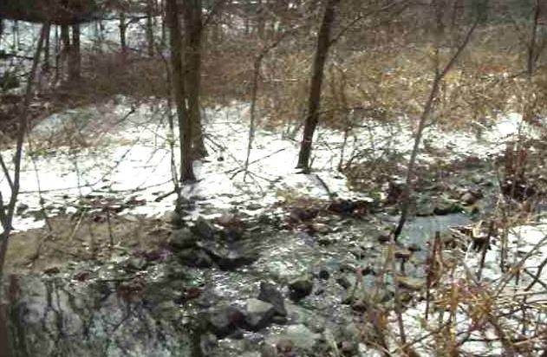  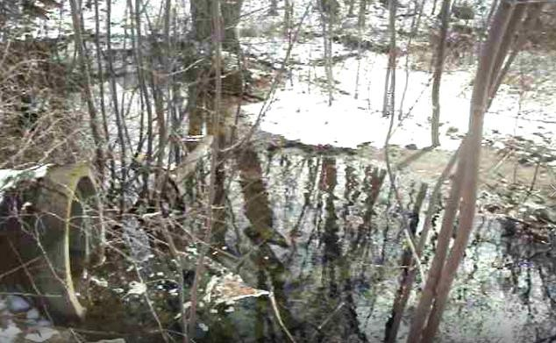  Grant: $34,769 Match:$11,590Total: $46,359 | Photo looking East from Apartment Complex at south facing culvert  Photo looking southeast at Western Branch

NPS Site Name  & Location | Describe the NPS Site & Conditions at the Site Causing Polluted Runoff to Reach Surface Waters | BMPs Recommended | Construction Cost BMP Site Ph Estimates:  Grant, Match, Total | otos
Name: Habitat Restoration Site 2  Location: From Pearl Street extending in a northwesterly direction for approximately 400 linear feet. | Goodall Brook from Roberts Street to Berwick Road was artificially straightened to drain what was historically a wetland area. In some locations, boards were placed within the base of the brook to “make it flow faster.” As a result, the brook has taken on the characteristics of a drainage channel and no longer holds the physical characteristics of a healthy stream. | Woody debris installations will be established to create flow complexity and habitat in the currently stagnant channel. It may utilize several different approaches: 1) single partially buried logs with root wads exposed; 2) low log sills fully spanning the channel and 3) marginal log jams that occupy more than half of the channel. There is concern however from neighbors of potential basement flooding. To address this issue and to design the best approach, a geomorphic assessment of current conditions, topographic surveying, and hydraulic modeling will be conducted. | Grant: $35,396 Match: $22,876 Total: $58,272  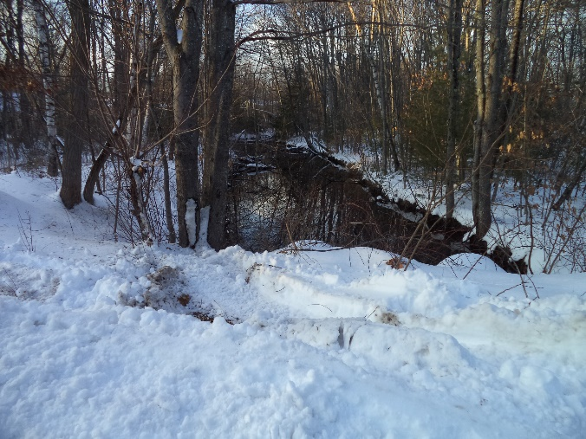  Example of stream conditions just above Berwick Road.

NPS Site Name  & Location | Describe the NPS Site & Conditions at the Site Causing Polluted Runoff to Reach Surface Waters | BMPs Recommended | Construction Cost BMP Site Ph Estimates:  Grant, Match, Total | oto
Name: Tree Box Filter  Location: Near the intersection of Kimball Street and Twombley Road | This area is developed with roadways, single-family dwellings, and paved parking lot surfaces and therefore surface runoff from the area contains pollutants from general site use and vehicles. In 2020, the City of Sanford contracted with Gorrill Palmer Inc. to design a road reconstruction project called West Side Village, which includes reconstruction of this area in 2021. Surface runoff in this area is directed into storm drains that discharge into an underground portion of Goodall brook making this spot ideal to redirect runoff from catch basins into a biotreatment system. | One to two tree box filter(s) are proposed to treat Twombley Road and Kimball street. They will be placed upstream of an existing or new catch basin on each street and connect back into the stormwater system before discharging to Goodall Brook and provide treatment to ~0.5 acres each. Both filter locations will be designed in flat sloped locations near their respective road low points in order to minimize high gutter flow velocities in the roadway, allowing the stormwater to more easily enter the curb inlet. The design will include separation of lower volume discharge from larger bypass stormwater, allowing treated flows to enter the brook separated from the bypass flows. | Grant: $0  Match: $30,800 Total: $30,800  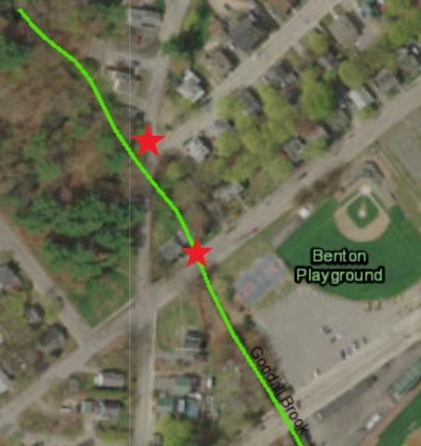  Two potential tree box filter locations

